|  |  |  |  |
| --- | --- | --- | --- |
|  | Bansilal Ramnath Agarwal Charitable Trust's  Vishwakarma Institute of Information Technology  **Department of**  **Artificial Intelligence and Data Science** | | |
| Name: Siddhesh Dilip Khairnar | | | |
| Class: SY | Division: B | | Roll No: 272028 |
| Semester: III | | Academic Year: 2022-2023 | |
| Subject Name & Code: Database Management System: ADUA21204 | | | |
| Title of Assignment: Design and Develop Mongo DB Queries using CRUD operations | | | |

**Assignment No.- 07**

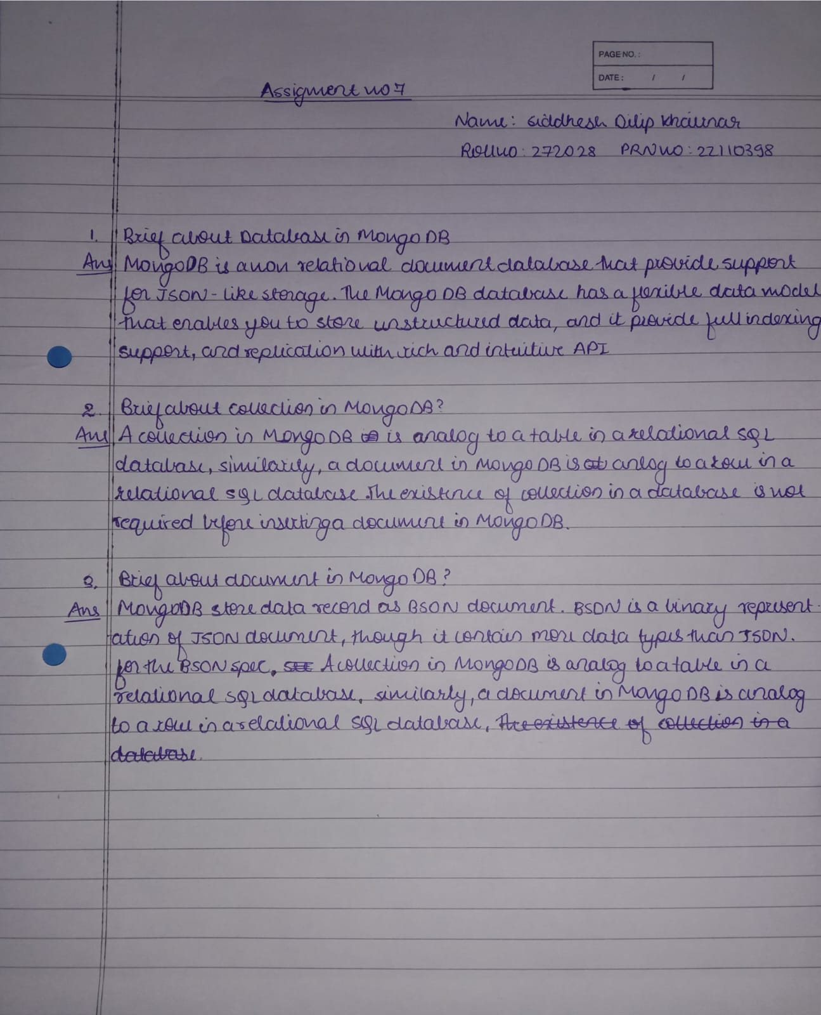

**Implementation:**

**1.** Creates a new database (here demo1) if it does not exist and switches to the database



**2.** Shows the current database



**3.** Shows list of databases which have at least one document in it or else it won’t be shown. Since “demo1” database does not have any document, it is not shown

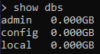

**4.** Creates collection (equivalent to tables in RDBMS) in the database



**5.** Shows collections



**6.** Inserts document (equivalent to rows in RDBMS) into the collection



**7.** To display the inserted documents

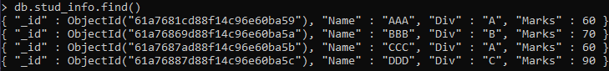

**8.** To display the inserted documents a little better

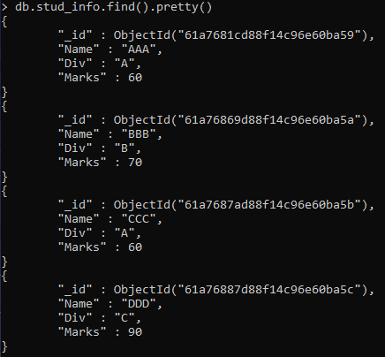

**9.** To update the particular values from the document and displaying the new updated result

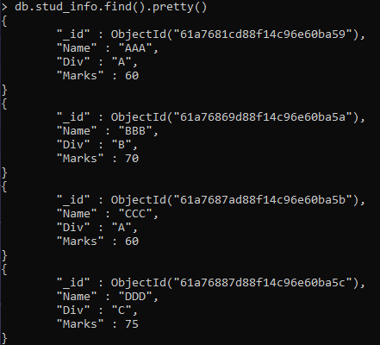

**10.**  Removing particular value from the collection and displaying the new deleted results

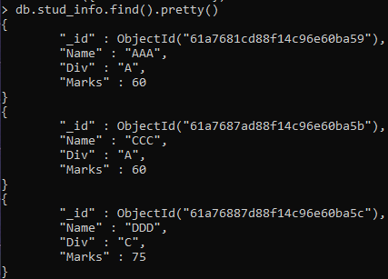

**11.** Since the database now has some value in it so it will be displayed

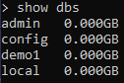

**12**. Deletes the collection from the database



**13.** Drops the current database

